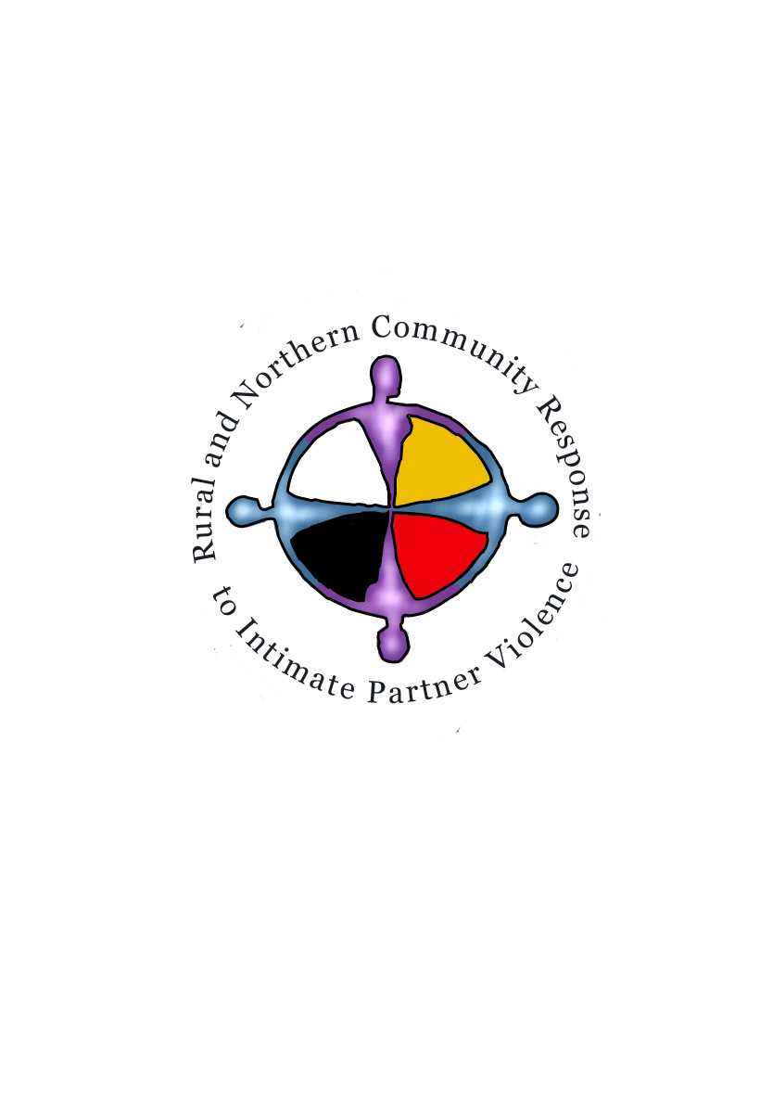SSHRC/CURA - RURAL AND NORTHERN COMMUNITY RESPONSE TO INTIMATE PARTNER VIOLENCE - PUBLIC MAP DISTRIBUTION
Summary of Research Project: The Rural and Northern Community Response to Intimate Partner Violence (IPV) examines the incidence of reported IPV assaults against women and the location of services available. Geography and dispersed populations in rural and northern Manitoba, Saskatchewan, Alberta and the Northwest Territories pose challenges in accessing services in times of crisis and need. GIS mapping can highlight the discrepancy between incidence and service. These maps are combined with qualitative interviews and community narratives to identify the unique needs of victims of IPV in rural and northern communities, to address the gaps in services to meet these needs and to motivate program and policy changes to close those gaps and model ways to create non-violent communities. This study is supported by the social Sciences and Humanities Research Council and is led by Dr. M. Hampton at University of Regina. For further information contact RESOLVE at University of Regina resolve@uregina.ca.
Map Description (map's content and how it informs the project - limit description to 7 lines):
Map Process (summary of how map was created, source of data, mapping process - limit description to 7 lines):
Map Limitations (limit description to 7 lines):
Map Uses: This map is offered for use under the terms of the Creative Commons License 4.0 (CC By-Nc-Nd 4.0). You may copy and redistribute the material in any medium or format so long as you do not alter the content or use it for commercial purposes, (https://creativecommons.org/licenses/by-nc-nd/4.0/). We request appropriate credit for the map is given and suggest the wording below for attribution.
Attribution and Authors (identify research group and specific regional team member contributions):

